1]. Real estate agents want help to predict the house price for regions in the USA. He gave you the dataset to work on and you decided to use the Linear Regression Model. Create a model that will help him to estimate what the house would sell for.

import pandas as pd
import numpy as np
import matplotlib.pyplot as plt
import seaborn as sns

from sklearn.model_selection import train_test_split
from sklearn.linear_model import LinearRegression
from sklearn import metrics

# Load dataset
df = pd.read_csv("USA_Housing.csv")

# Basic info
print(df.head())
print(df.info())
print(df.describe())
print(df.isnull().sum())

# Drop non-numeric column
df = df.drop('Address', axis=1)

# Pairplot (optional: comment if slow)
sns.pairplot(df)
plt.show()

# Correlation heatmap
plt.figure(figsize=(8,6))
sns.heatmap(df.corr(), annot=True, cmap='coolwarm')
plt.title("Correlation Matrix")
plt.show()

# Features & target
X = df.drop('Price', axis=1)
y = df['Price']

# Train-test split
X_train, X_test, y_train, y_test = train_test_split(
X, y, test_size=0.3, random_state=42
)

# Model training
model = LinearRegression()
model.fit(X_train, y_train)

# Coefficients
coeff_df = pd.DataFrame(model.coef_, X.columns, columns=['Coefficient'])
print("\nModel Coefficients:\n", coeff_df)

# Predictions
predictions = model.predict(X_test)

# Evaluation metrics
mae = metrics.mean_absolute_error(y_test, predictions)
mse = metrics.mean_squared_error(y_test, predictions)
rmse = np.sqrt(mse)
r2 = metrics.r2_score(y_test, predictions)

print("\nModel Evaluation:")
print(f"MAE : {mae:.2f}")
print(f"MSE : {mse:.2f}")
print(f"RMSE : {rmse:.2f}")
print(f"R² : {r2:.4f}")

# Scatter plot (Actual vs Predicted)
plt.figure(figsize=(6,6))
plt.scatter(y_test, predictions)
plt.xlabel("Actual Prices")
plt.ylabel("Predicted Prices")
plt.title("Actual vs Predicted Prices")
plt.show()

# Residual distribution
plt.figure(figsize=(6,4))
sns.histplot(y_test - predictions, bins=50)
plt.title("Residual Distribution")
plt.xlabel("Error")
plt.show()

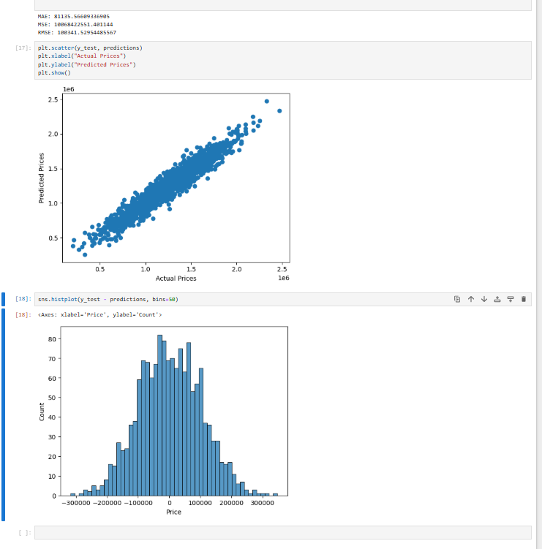

2]. Build a Multiclass classifier using the CNN model. Use MNIST or any other suitable dataset.
a. Perform Data Pre-processing b. Define Model and perform training c. Evaluate Results using confusion matrix.

import numpy as np
import matplotlib.pyplot as plt
import seaborn as sns

from tensorflow.keras.datasets import mnist
from tensorflow.keras.models import Sequential
from tensorflow.keras.layers import Conv2D, MaxPooling2D, Flatten, Dense
from tensorflow.keras.utils import to_categorical
from sklearn.metrics import confusion_matrix

(X_train, y_train), (X_test, y_test) = mnist.load_data()
X_train = X_train.reshape(-1, 28, 28, 1)
X_test = X_test.reshape(-1, 28, 28, 1)
X_train = X_train / 255.0
X_test = X_test / 255.0
y_train_cat = to_categorical(y_train, 10)
y_test_cat = to_categorical(y_test, 10)

model = Sequential()
model.add(Conv2D(32, (3,3), activation='relu', input_shape=(28,28,1)))
model.add(MaxPooling2D(pool_size=(2,2)))
model.add(Conv2D(64, (3,3), activation='relu'))
model.add(MaxPooling2D(pool_size=(2,2)))
model.add(Flatten())
model.add(Dense(128, activation='relu'))
model.add(Dense(10, activation='softmax'))

model.compile(optimizer='adam',loss='categorical_crossentropy',metrics=['accuracy'])
model.fit(X_train, y_train_cat, epochs=5, batch_size=64, validation_split=0.1)

loss, accuracy = model.evaluate(X_test, y_test_cat)
print("Test Accuracy:", accuracy)

y_pred = model.predict(X_test)
y_pred_classes = np.argmax(y_pred, axis=1)

cm = confusion_matrix(y_test, y_pred_classes)
plt.figure(figsize=(8,6))
sns.heatmap(cm, annot=True, fmt='d', cmap='Blues')
plt.xlabel("Predicted")
plt.ylabel("Actual")
plt.title("Confusion Matrix")
plt.show()
print("\nClassification Report:\n")
print(classification_report(y_test, y_pred_classes))

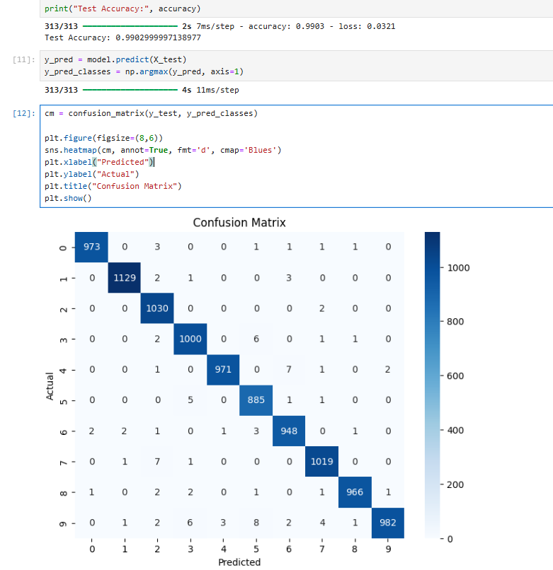

4]. Design and implement a CNN for Image Classification a) Select a suitable image classification dataset (medical imaging, agricultural, etc.). b) Optimized with different hyper-parameters including learning rate, filter size, no. of layers, optimizers, dropouts, etc.

import numpy as np
import matplotlib.pyplot as plt

from tensorflow.keras.datasets import cifar10
from tensorflow.keras.models import Sequential
from tensorflow.keras.layers import Conv2D, MaxPooling2D, Flatten, Dense, Dropout
from tensorflow.keras.utils import to_categorical
from tensorflow.keras.optimizers import Adam

(X_train, y_train), (X_test, y_test) = cifar10.load_data()

X_train = X_train / 255.0
X_test = X_test / 255.0
y_train = to_categorical(y_train, 10)
y_test = to_categorical(y_test, 10)

def build_model(learning_rate=0.001, dropout_rate=0.5, filters=32):
model = Sequential()
# Conv Layer 1
model.add(Conv2D(filters, (3,3), activation='relu', input_shape=(32,32,3)))
model.add(MaxPooling2D((2,2)))
# Conv Layer 2
model.add(Conv2D(filters*2, (3,3), activation='relu'))
model.add(MaxPooling2D((2,2)))
# Conv Layer 3
model.add(Conv2D(filters*4, (3,3), activation='relu'))
model.add(Flatten())
model.add(Dense(128, activation='relu'))
model.add(Dropout(dropout_rate))
model.add(Dense(10, activation='softmax'))
optimizer = Adam(learning_rate=learning_rate)
model.compile(optimizer=optimizer,
loss='categorical_crossentropy',
metrics=['accuracy'])
return model

model1 = build_model(learning_rate=0.001, dropout_rate=0.5, filters=32)
history1 = model1.fit(X_train, y_train, epochs=10, batch_size=64, validation_split=0.2)

model2 = build_model(learning_rate=0.0005, dropout_rate=0.3, filters=64)
history2 = model2.fit(X_train, y_train, epochs=5, batch_size=64, validation_split=0.2)

loss1, acc1 = model1.evaluate(X_test, y_test)
loss2, acc2 = model2.evaluate(X_test, y_test)

print("Model 1 Accuracy:", acc1)
print("Model 2 Accuracy:", acc2)

plt.plot(history1.history['val_accuracy'], label='Model 1')
plt.plot(history2.history['val_accuracy'], label='Model 2')
plt.legend()
plt.title("Validation Accuracy Comparison")
plt.show()
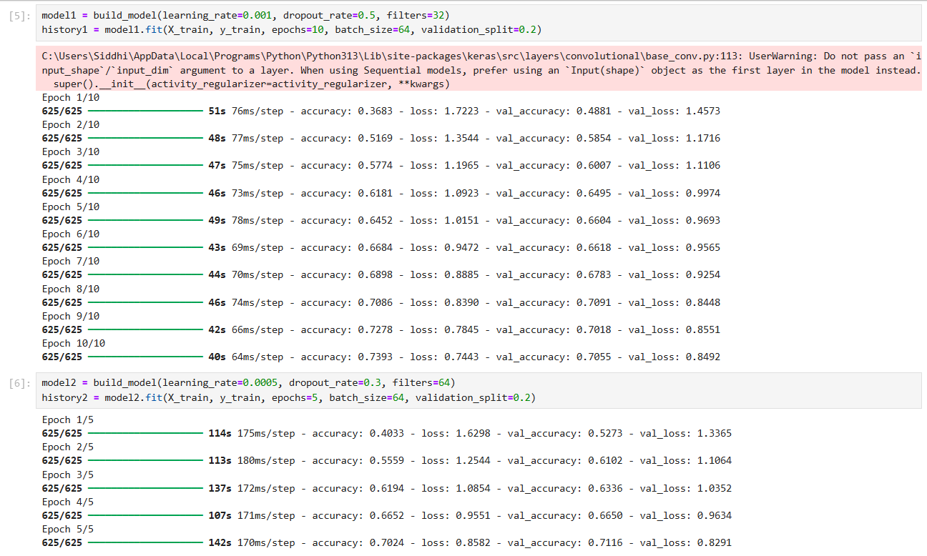
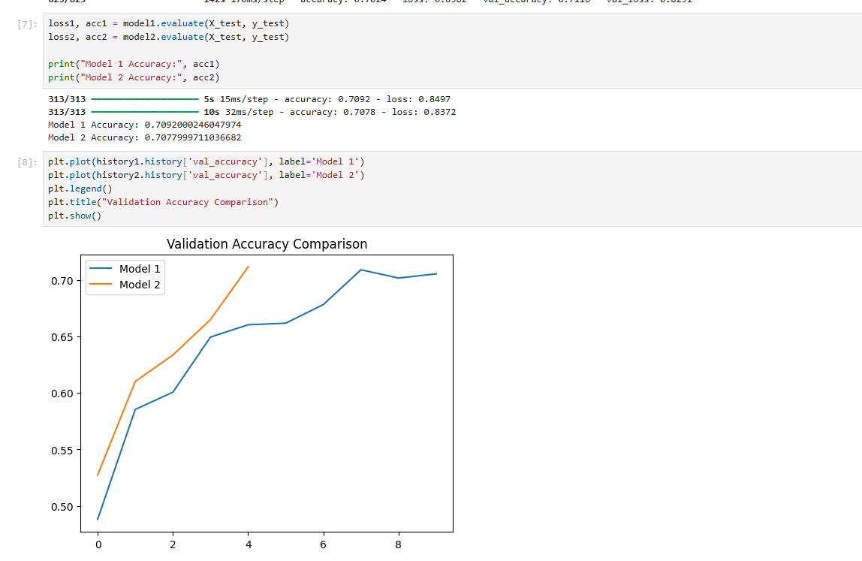

5]. Design and implement Deep Convolutional GAN to generate images of faces/digits from a set of given images.

import numpy as np
import matplotlib.pyplot as plt

from tensorflow.keras.datasets import mnist
from tensorflow.keras.models import Sequential
from tensorflow.keras.layers import Dense, Reshape, Flatten
from tensorflow.keras.layers import Conv2D, Conv2DTranspose
from tensorflow.keras.layers import LeakyReLU, Dropout, BatchNormalization
from tensorflow.keras.optimizers import Adam
from tensorflow.keras import Input

(X_train, _), (_,_)=mnist.load_data()
X_train = (X_train - 127.5)/127.5
X_train = X_train.reshape(X_train.shape[0], 28,28,1)

def build_generator():
model = Sequential()
model.add(Input(shape=(100,)))
model.add(Dense(128 * 7 * 7))
model.add(LeakyReLU(0.2))
model.add(Reshape((7, 7, 128)))
model.add(Conv2DTranspose(128, 4, strides=2, padding='same'))
model.add(BatchNormalization())
model.add(LeakyReLU(0.2))
model.add(Conv2DTranspose(64, 4, strides=2, padding='same'))
model.add(BatchNormalization())
model.add(LeakyReLU(0.2))
model.add(Conv2D(1, 7, activation='tanh', padding='same'))
return model

def build_discriminator():
model = Sequential()
model.add(Input(shape=(28,28,1)))
model.add(Conv2D(64, 3, strides=2, padding='same'))
model.add(LeakyReLU(0.2))
model.add(Dropout(0.))
model.add(Conv2D(128, 3, strides=2, padding='same'))
model.add(LeakyReLU(0.2))
model.add(Dropout(0.3))
model.add(Flatten())
model.add(Dense(1, activation='sigmoid'))
return model

# Build discriminator
discriminator = build_discriminator()
discriminator.compile(loss='binary_crossentropy',
optimizer=Adam(0.0001, 0.5),
metrics=['accuracy'])

# Build generator
generator = build_generator()

# Freeze discriminator for GAN
discriminator.trainable = False

# Build GAN
gan = Sequential([generator, discriminator])
gan.compile(loss='binary_crossentropy',
optimizer=Adam(0.0001, 0.5))

def train(epochs=5000, batch_size=64):
half_batch = batch_size // 2
for epoch in range(epochs):
# Train Discriminator
discriminator.trainable = True
idx = np.random.randint(0, X_train.shape[0], half_batch)
real_imgs = X_train[idx]
noise = np.random.normal(0, 1, (half_batch, 100))
fake_imgs = generator.predict(noise, verbose=0)
# Label smoothing + noise
real_labels = np.ones((half_batch,1)) * 0.9
fake_labels = np.zeros((half_batch,1))
real_labels += 0.05 * np.random.random(real_labels.shape)
fake_labels += 0.05 * np.random.random(fake_labels.shape)
# Train discriminator LESS (important)
if epoch % 2 == 0:
d_loss_real = discriminator.train_on_batch(real_imgs, real_labels)
d_loss_fake = discriminator.train_on_batch(fake_imgs, fake_labels)
# Train Generator
discriminator.trainable = False
noise = np.random.normal(0, 1, (batch_size, 100))
g_loss = gan.train_on_batch(noise, np.ones((batch_size,1)))
# Print progress
if epoch % 1000 == 0:
print(f"Epoch {epoch} [G loss: {g_loss:.4f}]")
save_images(epoch)

def save_images(epoch):
noise = np.random.normal(0, 1, (16, 100))
gen_imgs = generator.predict(noise, verbose=0)
gen_imgs = 0.5 * gen_imgs + 0.5
plt.figure(figsize=(4,4))
for i in range(16):
plt.subplot(4,4,i+1)
plt.imshow(gen_imgs[i,:,:,0], cmap='gray')
plt.axis('off')
plt.show()

train(epochs=5000)

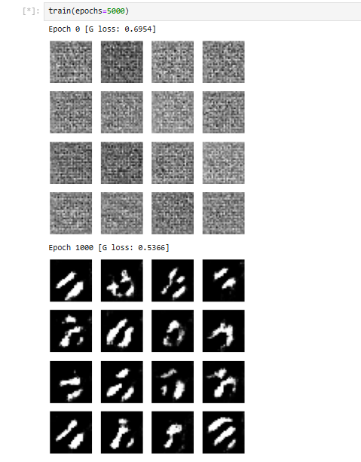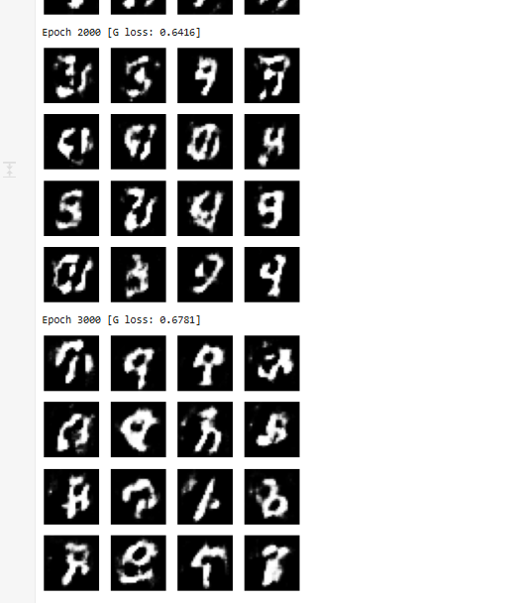

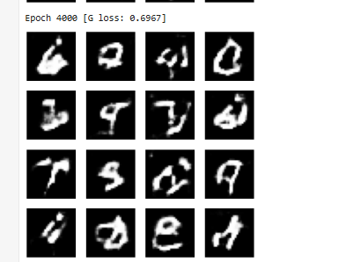

6]. Perform Sentiment Analysis in the network graph using RNN.
import numpy as np
import matplotlib.pyplot as plt
import seaborn as sns

from tensorflow.keras.datasets import imdb
from tensorflow.keras.models import Sequential
from tensorflow.keras.layers import Embedding, LSTM, Dense
from tensorflow.keras.preprocessing.sequence import pad_sequences

from sklearn.metrics import confusion_matrix

vocab_size = 10000

(X_train, y_train), (X_test, y_test) = imdb.load_data(num_words=vocab_size)
max_len = 200

X_train = pad_sequences(X_train, maxlen=max_len)
X_test = pad_sequences(X_test, maxlen=max_len)
model = Sequential()

model.add(Embedding(input_dim=vocab_size, output_dim=128))
model.add(LSTM(64))
model.add(Dense(1, activation='sigmoid'))

model.compile(loss='binary_crossentropy',optimizer='adam',metrics=['accuracy'])
model.fit(X_train, y_train,epochs=3,batch_size=64,validation_split=0.2)
loss, accuracy = model.evaluate(X_test, y_test)
print("Accuracy:", accuracy)
from sklearn.metrics import classification_report

print(classification_report(y_test, y_pred_classes))
y_pred = model.predict(X_test)
y_pred_classes = (y_pred > 0.5).astype(int)

cm = confusion_matrix(y_test, y_pred_classes)

sns.heatmap(cm, annot=True, fmt='d')
plt.xlabel("Predicted")
plt.ylabel("Actual")
plt.show()

